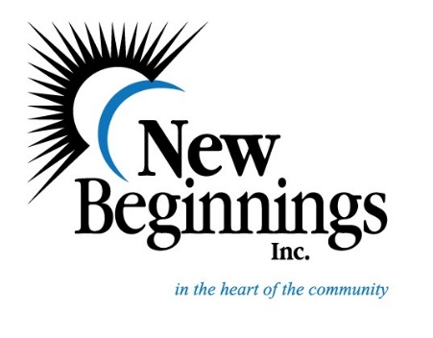

All items donated will benefit the New Beginnings NOEL Lodge. An overnight emergency shelter for men, women and families. Your help is appreciated.
New Beginnings Inc., has been part of the Hutchinson Community for more than 30 years and NOEL Lodge has been serving the homeless population for over 6 years. New Beginnings Inc., is a 501c 3 not-for-profit organization.

Butter
Sugar
Peanut Butter
Jelly
Coffee
Coffee Filters
Creamer
Corn
Green Beans
Carrots
Peas
Black/Pinto Beans
Instant Potatoes
Cereal
Oatmeal Packages

Paper plates
Paper Bowls
Plastic Cups
Styrofoam Cups

Toilet Paper
Body Wash
Shampoo
Conditioner
Men’s Deodorant
Lotion

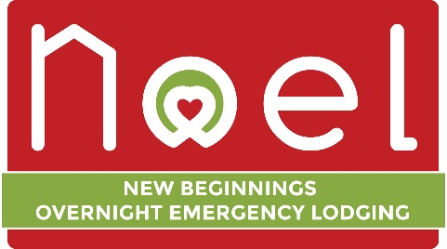

Toilet Bowl Cleaner
Bleach
All Purpose Cleaner
Dishwasher Detergent
Laundry Detergent
Dryer Sheets
30 Gallon Trash Bags
13 Gallon Trash Bags
Paper Towels

